

*Organisation: Solar Boat Sealander*

*Client: Mr. R. Eijlers*

*Tutor: Mr. W. Haak*

*Date: 22-10-2020*

Research Proposal

Propulsion system simulation

Fangzhou chen Jiacong li Marco Hoogesteger Martijn Crombeen

2020

Table of content

1. Organization 3

1.1 Client information 3

1.2 Academy details 3

1.3 Student Information 3

1.4 Hierarchy 4

2. Introduction 5

2.1 Background 5

2.2 Problem statement 5

2.2.1 Main question 6

2.2.2 Subtopic 1 6

2.2.3 Subtopic 2 6

2.2.4 Subtopic 3 6

2.2.5 Subtopic 4 6

2.2.6 Subtopic 5 6

2.2.7 Subtopic 6 6

2.2.8 Subtopic 7 6

2.2.9 Subtopic 8 6

2.3 Goals and objectives 7

2.3.1 Goal 7

2.3.2 Objectives 7

2.3.3 Boundaries 7

2.4 Requirements 8

3. Theoretical framework 9

3.1 Operational characteristics of propulsion components 9

3.2 Input power 9

3.3 Factors affecting the propulsion system 9

3.3.1 Internal factors 10

3.3.2 External factors 10

3.4 Power loss in the gearbox 10

3.4.1 Power loss in the gears 11

3.4.2 Power loss in the bearings 12

3.4.3 Power loss in shaft 14

3.4.4 Power loss in propeller 14

3.5 Simulate the resistance caused by wind 14

3.6 Simulation of the resistance caused by waves 15

3.7 Simulation of the resistance caused by ocean current 16

3.8 Define the output power of a ship's propulsion system 16

4. Method 19

4.1 Overview 20

4.2 Reasons of choice 20

4.3 Usage of method 21

5. Bibliography 22

# Organization

This project is being executed by students of the mechatronics course at the HZ University of Applied Sciences, in cooperation with exchange students from the SMU in China. The following sections will state general information about the client and project members.

## Client information

Organisation: Solar boat Sealander

Address: Edisonweg 4

Location: Vlissingen

Postal code: 4382 NW

Name client: Ronald Eijlers

E-mail: [ronald.eijlers@hz.nl](mailto:ronald.eijlers@hz.nl)

## Academy details

Company: HZ University of applied sciences

Address: Edisonweg 4

Location: Vlissingen

Postal code: 4382 NW

Phone: +31(0)118 489 000

Name tutor: Willem Haak

Phone: +31(0) 6 48197930

E-mail: [w.haak@hz.nl](mailto:w.haak@hz.nl)

## Student Information

Name: Martijn Crombeen

Student#: 73398

Phone: +31(0) 6 37120741

E-mail: [crom0004@hz.nl](mailto:crom0004@hz.nl)

Background: Mechatronics

Project Role: Project leader / contact person

Name: Marco Hoogesteger

Student#: 76556

Phone: +31(0)6 28726699

E-mail: [hoog0097@hz.nl](mailto:hoog0097@hz.nl)

Background: Mechatronics

Project Role: Project member

Name: Jiacong Li

Student#: 82749

Phone: +31(0) 6 45637440

E-mail: [li0042@hz.nl](mailto:li0042@hz.nl)

Background: Electrical Engineering

Project Role: Project member

Name: Fangzhou Chen

Student#: 82753

Phone: +31(0) 6 83159840

E-mail: [chen0061@hz.nl](mailto:chen0061@hz.nl)

Background: Mechatronics

Project Role: Project member

## Hierarchy

Figure 1 Group hierarchy

# Introduction

## Background

Solar powered travel is something that has been booming for the last few years. It can clearly be seen that current developments such as global warming have a very negative impact on the environment. Many recent studies and projects have been finding and experimenting with different environmentally friendly solutions to combat this rising trend. One of these solutions is the use of solar energy. The HZ also contributes to this research with their solar boat. This boat is being developed by a team of students from different areas, and is used to compete in yearly solar boat races. There, the teams have to face off against other students with different boats.

This project has been running since 2015 and multiple changes have been made to the boat. In the current rendition of the boat, the hull and structure are made out of fiberglass. Because this material is not eco-friendly, the next generation will be made out of mostly biobased materials. Together with this change, the main contents of the boat will get an overhaul too. The main drivetrain components will be revamped by two groups of 4th year students.

## Problem statement

The current propulsion system on the solar boat can realize the function of propelling boat and controlling direction. But the narrow and long blades of the propeller cause high friction when the propeller is rotating and in contact with water. Because of the small contact area between the blades and water, the thrust output from propeller cannot be transformed fully into high propulsion speed of the boat. Another issue is that some components of the propulsion system are heavy, which increases the burden of the propulsion system and effects the energy conversion efficiency (rotational kinetic energy as input from motor and output as thrust from propeller).

Basing on the above problem analyzation, three main research direction can be followed:

* Change the size of the propeller to reduce energy consumption caused by friction.
* Change the shape of blades to produce high thrust and increase the propulsion speed.
* Check every component of propulsion system and reduce weights of propulsion system to improve energy conversation efficiency.

To find out what size and shape of the propellor, and what parameters of the drivetrain are optimal, it is needed to perform a simulation of the different components and calculate where the improvements must take place.

### Main question

What is the verified simulation to calculate the propulsion system of the Solar boat to improve its efficiency (to aid the choice of components)?

### Subtopic 1

What is the demo test plan?

### Subtopic 2

What is the system test plan?

### Subtopic 3

What is the subsystem test plan?

### Subtopic 4

What is the component test plan?

### Subtopic 5

What is the component test?

### Subtopic 6

What is the subsystem test?

### Subtopic 7

What is the system test?

### Subtopic 8

What is the customer acceptation?

## Goals and objectives

### Goal

The goal of this project is to satisfy the client, by developing simulations that will provide information and support not only for this particular project, but for every new version of the boat that will be built.

### Objectives

* A verified simulation built in Excel.
  + User-friendly interface.
  + Easy to learn.
* Calculation chain.

### Boundaries

In this project, simulations are built and validated focused on designing a new propulsion system. It is easy to go to deep in the project resulting in an inadequate final result. To prevent this, it is very important to set project boundaries. After discussion and consideration with the client and the group members, the project boundary has been set as followed.

Simulations regarding the propeller, shaft, bearings and gearing will be made. With all these simulations, we can calculate the ideal torque and revolutions that the driveshaft has to receive from the motor. The Engineer that is going to design the whole new propulsion system and select components, can use this information to select the desired motor.

Figure 2 shows a simple block diagram displaying the project boundary.

Figure 2 System block diagram

In the theoretical framework below, all kind of factors are displayed that could have some kind of influence on the performance of the propulsion system. A very difficult part of this are the variable properties of water. Ocean water can contain current, waves or different compositions, that all can lead to variable outcomes. For this project we stated that we don’t take the variables linked to water in account.

## Requirements

|  |  |
| --- | --- |
| Requirements List | |
| List of clients’ requirements | | **Demand** | **Wish** |
| 1. | The propeller blades can provide high propulsive force. |  |  |
| 3. | The final deliverable work surprises the client. |  |  |
| 4. | The prototype is a calculation chain. |  |  |
| 5. | The client thinks the interface of the simulation is user-friendly. |  |  |
| 6. | Data is measured from the real setup for the verification of the calculation chain. |  |  |
| 7. | The propulsion system will be more efficient. |  |  |
| 10. | The input power of the shaft will be a variable in the simulation and then an ideal setting can be determined. |  |  |
| 11. | The errors between the results derived from the calculation chain and the results from the real Solar boat do not exceed 30%. |  |  |
| 12. | The calculation chain only focusses on the propulsion system so external resistances from water are not taken in to account. |  |  |
| 13. | All data are kept to two decimal places. |  |  |
| 14. | Provide some efficient component selection direction for those who design the boat’s propulsion system. |  |  |
| 16. | The correct formulas will be chosen to make the calculation chain. |  |  |
| 17. | The V-model is used as method. |  |  |
| 18. | The demo test plan is made. |  |  |
| 19. | The system test plan is made. |  |  |
| 20. | The subsystem test plan is made. |  |  |
| 21. | The component test plan is made. |  |  |
| 22. | The component test is made. |  |  |
| 23. | The subsystem test is made. |  |  |
| 24. | The system test is made. |  |  |
| 25. | The client is satisfied. |  |  |

Figure 3 Requirements list

# Theoretical framework

## Operational characteristics of propulsion components

This paper is aiming to reveal the details of energy conversion through of the solar boat’s propulsion system so that researchers can build a calculation chain to simulate and optimize the propulsion system with a higher efficiency. The solar boat’s propulsion system which consists of the electric motor (prime mover), the gearbox and shaft (transmission system) and the propeller (propulsor). Furthermore, the thrust delivered by the propeller has to overcome the ship’s resistance, which strongly depends upon the external forces that impose to the boat. So the wind and waves have been considered (Shi1 & Grimmelius, 2009).

## Input power

The energy of the propulsion system comes from the electric motor that is powered by the batteries, who in turn are powered by solar panels.

## Factors affecting the propulsion system

In the process of energy transmission, the output power of the motor cannot be completely converted into the output power of the propeller due to the influence of some factors. And due to the influence of other external factors, the propulsion power output by the propeller needs to overcome a series of resistances to result in the force that accelerates the solarboat.

The efficiency of the conversion of solar power to a moving solarboat could be divided into four parts; the hull efficiency, the propeller efficiency, the transmission efficiency and the engine efficiency. Since our boundary does not include the hull and motor, it was decided to use a fixed value to represent the hull resistance, which together with the output power from the motor is used as the input of the system (Shi1 & Grimmelius, 2009).

Motor

Input Power

Output Propulsion Force

Figure 4: block diagram losses

Propulsion System

Internal Power Loss

External Power Loss

### Internal factors

Transmission efficiency and propeller efficiency are the main parts of the internal energy loss factors. The researchers figured out which components mainly caused the energy loss of these two parts. The main energy loss happened in the gearbox and propellers.

### External factors

The external energy loss mainly comes from wind and waves and the resistance of the hull. The researchers set the hull's own resistance to a fixed value. For the wind & waves in the ocean, the current intensity value is used, as they related to the Dutch sea area which is used in the simulation of the propulsion system of the solar ship.

## Power loss in the gearbox

The power loss in a gearbox is caused by gears, bearings, and seal and auxiliary losses (Klaus Michaelis, 2011). Gear and bearing losses can be separated into no-load losses, which occur even without power transmission. Except for the working conditions and the air gap in the gearbox, no-load losses are mainly caused due to lubricant viscosity and density, while the immersion depth of the components dipping into the lubricant also contribute to the no-load losses.

Load-losses depend on transmitted load, coefficient of friction and sliding velocity in the contact areas of the components. The power loss in gears is typically dominant in the nominal power transmission situation. For part load and high speed, high no-load losses dominate the total losses. For optimizing the whole operating range of a gearbox, it is needed to simulate the transmission flow using a calculation chain. In the following topics, the major factors that lead to gearbox power losses mainly consider the bearings & gears and shaft.

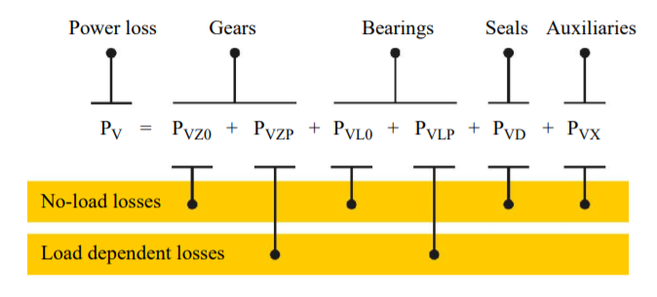

Figure 5 Composition of transmission power loss

### Power loss in the gears

#### No-load gear losses

The no-load gear losses ensue from immersion depth in sump lubricated gearboxes & lubricant viscosity in operating conditions. Since the operating conditions are uncontrollable, the immersion depth in lubricant and lubricant viscosity will be mainly concerned.

For immersion depth in a sump lubricated gearbox, the immersion depth of the gear will affect the meshing of the gear and cause the loss of energy. Therefore, at different immersion depths, the gear loss in this part is different (Lin Zou, 2018).

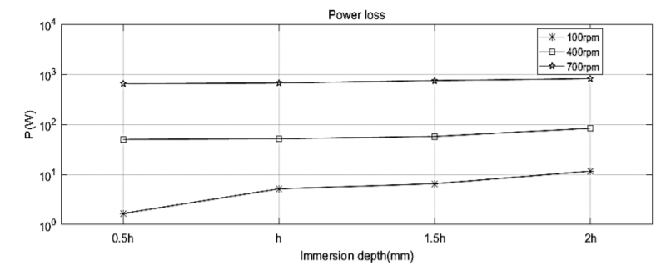

Figure 6 the effect of the immersion depth on power loss at three different speeds

In Figure 6 it can be seen that high immersion depth may lead to higher energy loss, which is caused by lubricant resistance. But in order to prevent rust, reduce friction, heat dissipation and other disadvantages, we cannot blindly reduce the lubricant immersion depth. It is therefore crucial to find a suitable lubricant immersion depth range, which can achieve less energy loss and satisfy its function (Lauer, 2013).

The energy loss due to the lubricant mainly depends on the viscosity of the lubricant. High-viscosity lubricants will increase churning loss. The viscosity of the lubricant decreases with increasing temperature. When the load is immense, the lubricant with a high viscosity is suitable and when the speed is high, the lubricant with a low viscosity is suitable. Suitable lubricants are therefore needed for the solar boat (k.Michaelis&B.-R.Hohn).

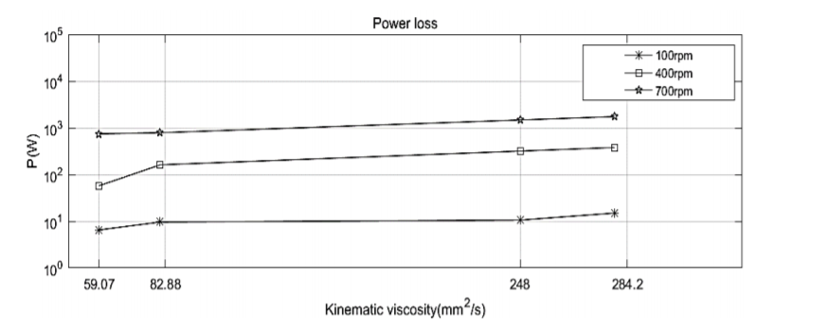

Figure 7 the effect of the viscosity on the power loss at three different speeds

From figure 7, it can be derived that the energy loss of high-speed gears is greater than that of low-speed gears.

#### Load dependent losses

The load gear losses in the mesh while power is transmitted follow the basic Coulomb law: (Klaus Michaelis, 2011)

with:

The calculation of and will be defined in the final report. From the formula, we can infer that the load energy loss is related to the roughness of the gear and the relative speed of the gear contact surface. Although lubricant will cause no-load energy loss, it can also reduce load energy loss.

### Power loss in the bearings

The energy loss in the bearings can also be divided into no-load loss and load dependent loss. The no-load loss in a bearing is mainly caused by the type and size of the bearing, the arrangement of the bearing, and the viscosity and supply of the lubricant (Klaus Michaelis, 2011). Figure 8 shows the no-load power loss difference between bearing types.

The radial bearing has the lowest no-load loss. Roller bearings with a small taper are suitable for no-load bearing arrangements. When considering the cross load, axial preloading is required, which greatly increases the no-load energy loss of the tapered roller.

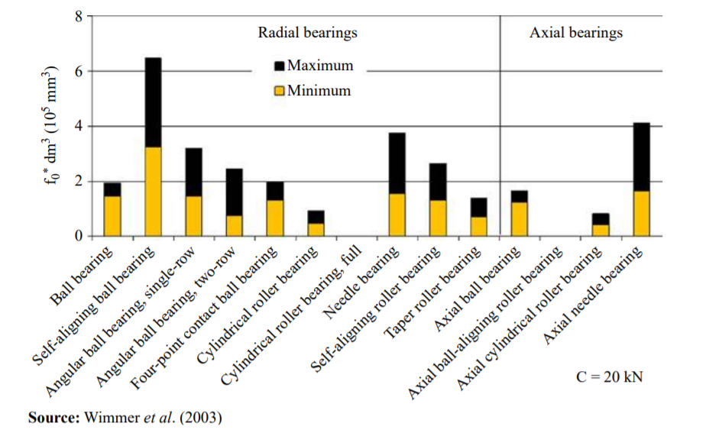

Figure 8 Influence of bearing type on no-load losses

When it comes to load-dependent losses, the causes are different. The load dependent losses depend on bearing type and size, on load and sliding conditions in the bearing and on the lubricant type. Figure 9 shows load-dependent losses of the bearing with same load capacity C = 20 [kN].

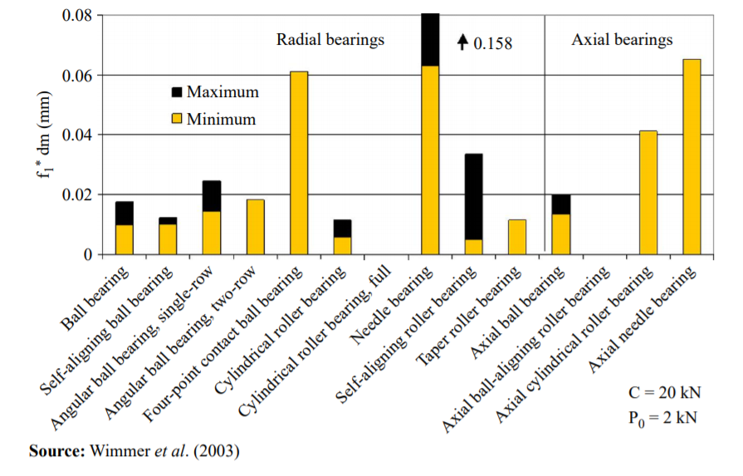

Figure 9 Influence of bearing type on load losses

Cylindrical rollers have the lowest axial power loss. Under the same load, tapered rollers have small energy losses due to their smaller diameter.

### Power loss in shaft

Since power is a function of speed and torque, the speed will not be affected by the length of the shaft, but the torque will. The length of the shaft has an effect on torsional (twisting) stiffness. The longer it is, the less stiff it will be. If the torque on the shaft is varying a lot, then the changes in torque are damped by the deflection of the shaft. If the shaft is under constant torque, the torque loss is almost zero, but in real life the load is not constant. So the length of the shaft will affect the energy loss.

Friction on the shaft can also cause energy loss, so lubricants are needed to help reduce losses caused by friction.

### Power loss in propeller

The propeller is used to generate thrust to overcome the ship resistance. Normally, an open water diagram is used to determine the operational behaviour of the propeller. That is because realistic waters and open waters are rarely the same. Energy loss occurs when the power of the propeller in open water is converted into actual propeller power (Shi1 & Grimmelius, 2009).

## Simulate the resistance caused by wind

Wind is considered an external energy resistance. Since the wind is not fixed and varies from day to day, the researchers found the average wind value of the Dutch sea detected by the testing station. This mean value is used as the input value of the calculation chain.

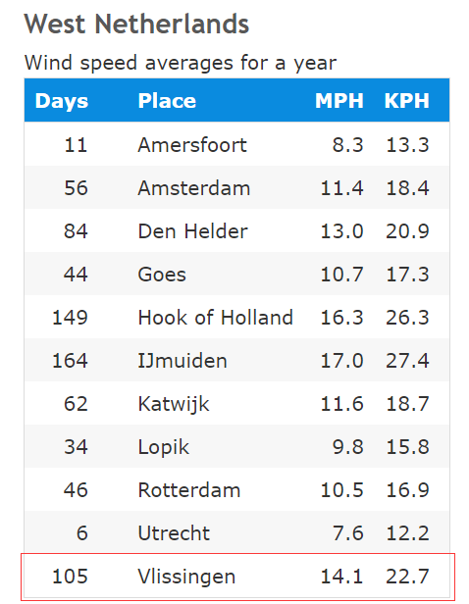

Figure 10 West Netherlands wind speed averages for a year

(Annual Average Wind Speeds in the Netherlands, 2010)

Figure 10 shows the average wind speed for a year in miles per hour [MPH] and kilometres per hour [KPH]. All the numbers here are based on weather data collected from 1981 to 2010.

## Simulation of the resistance caused by waves

A wave is considered an external energy resistance. Since Vlissingen does not have a wave detection point, the researchers decided to use data near Honte nabij Sloehaven as the wave input (Waterinfo-Wave, 2020).

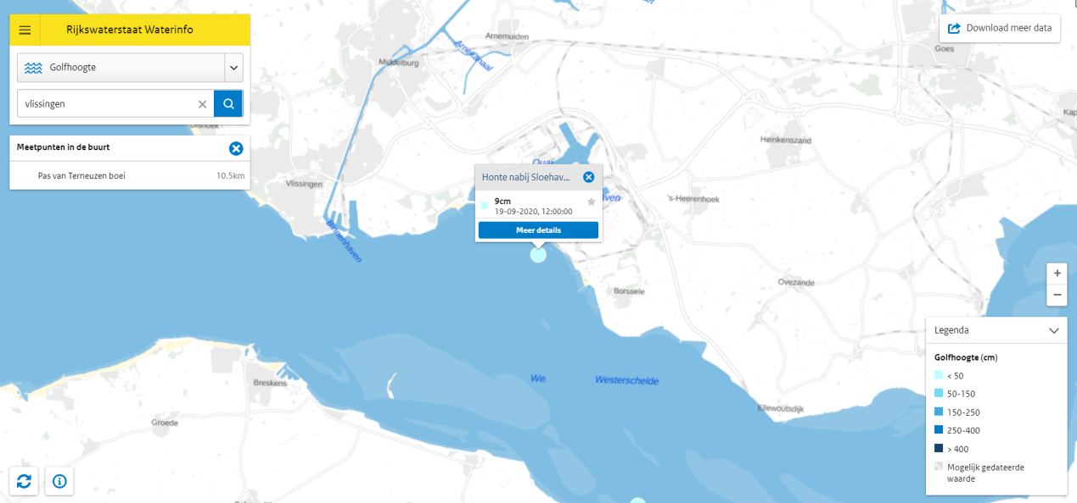

Figure 11 Wave height detection near Vlissingen

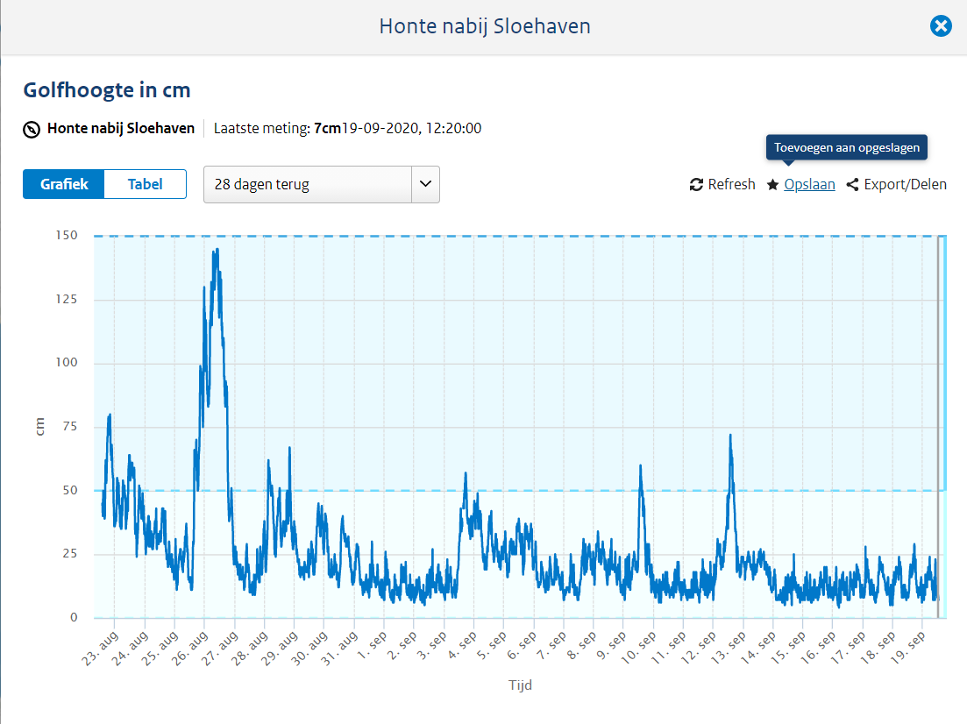

Figure 12 Wave height data of the past month

It can be seen from Figure 12 that the wave data fluctuates greatly, but the data is concentrated around 10cm.

## Simulation of the resistance caused by ocean current

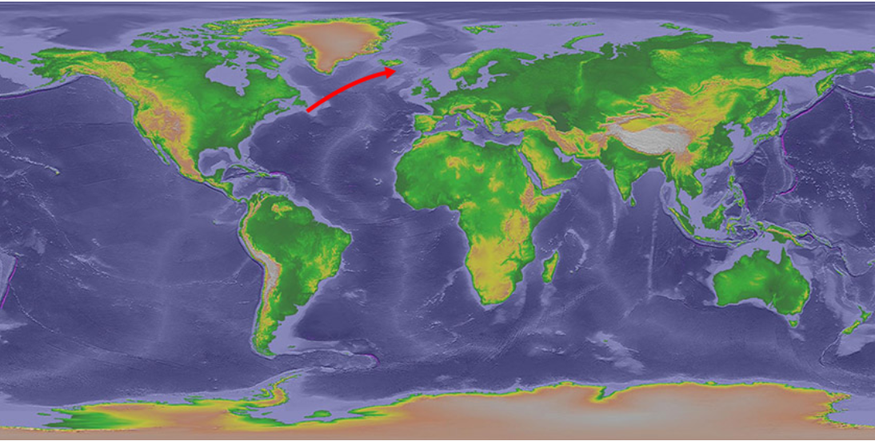

Figure 13 North Atlantic current

(Major Ocean Currents, n.d.)

The ocean current surrounding the Netherlands is the North Atlantic Warm Current, the most powerful warm current in the northern Atlantic Ocean, and is a continuation of the Gulf Stream. The North Atlantic warm current runs from southwest to northeast (North Atlantic Current, n.d.). The direction of the ocean current will affect the navigation of the ship. Although the solar boat is driven by a Propeller which is less dependent on ocean currents and winds, all ships can benefit from making good use of ocean currents. According to research, ocean currents in offshore areas can be ignored (Willemsen, 2019).

## Define the output power of a ship's propulsion system

When studying the final output power of the propulsion system, the output power can be estimated by calculating the displacement of the propeller and velocity pf the water. Or installing a force sensor behind the propeller to detect the thrust generated by the propeller.

According to the formula, we need to get the thrust generated by the propeller and the speed of the water, and we can calculate the power output by the propeller.

Or you can measure the volume of water (V) that the propeller discharges in the rated time (t) and the distance (s) of the boat movement. The volume of water multiplied by the density of the water () can be used to calculate the mass of discharged water so as to calculate the power output of the propeller.

## Motor characteristic curve

### Motor drawings and data provided by suppliers

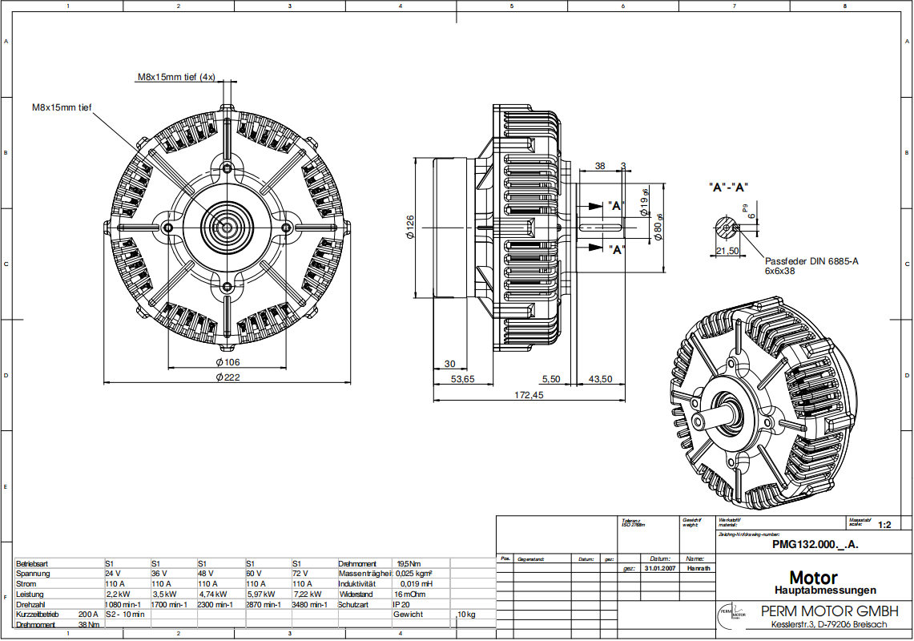

Figure 14 Motor drawing

|  |  |  |
| --- | --- | --- |
| Motor parameters | | |
| Pole pair | Coils | Current | |
| 4 | 20 | 110A | |
| Voltage (V) | Rotation speed (rpm) | Power (kw) | |
| 24 | 1080 | 2,2 | |
| 36 | 1700 | 3,5 | |
| 48 | 2300 | 4,74 | |
| 60 | 2870 | 5,97 | |
| 72 | 3480 | 7,22 | |

Figure 15 Motor parameters

Since the voltage provided by the battery is around 48 [V], the characteristic curve is chosen accordingly.

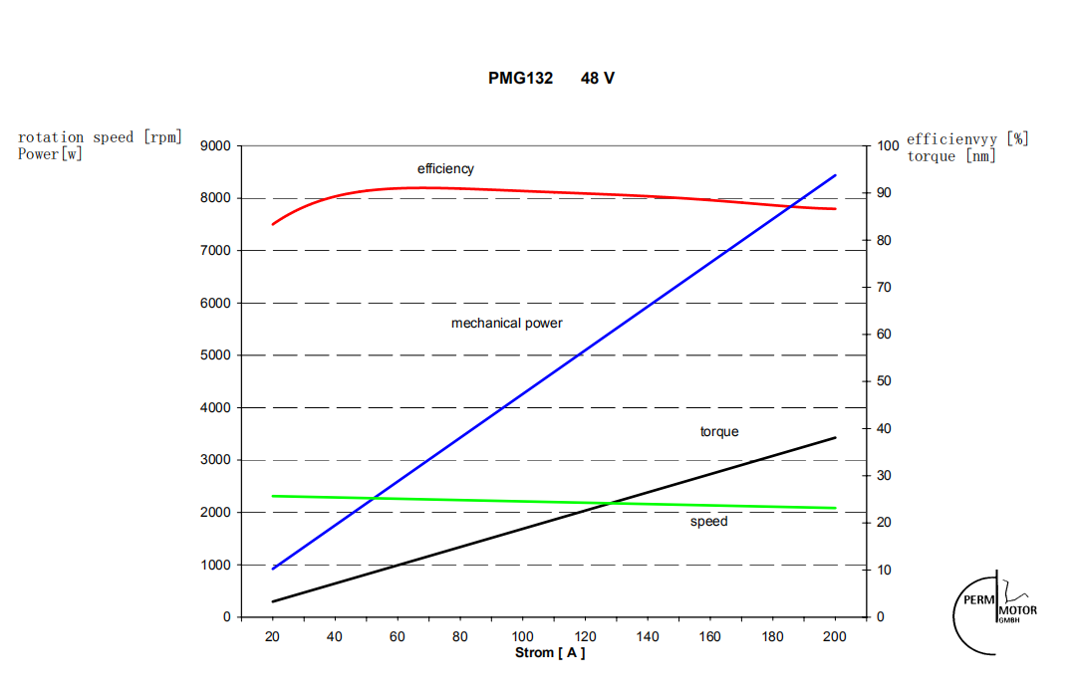

Figure 16 Motor curve 48 [V]

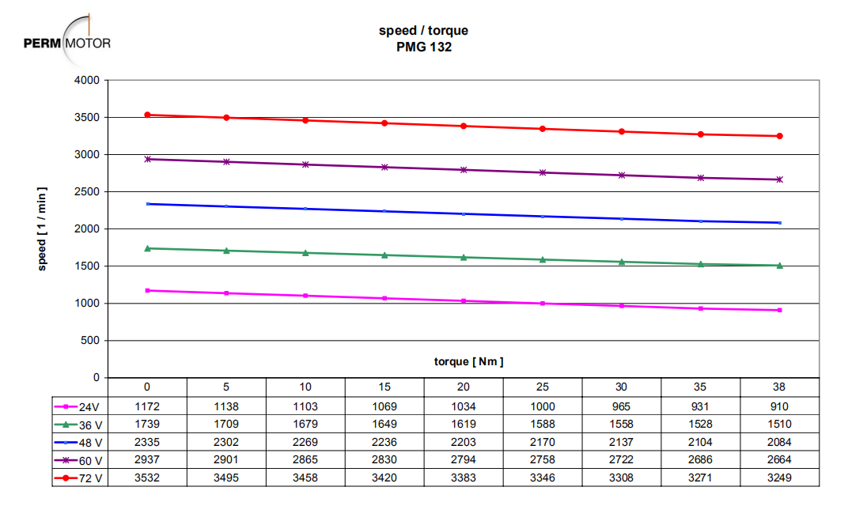

Figure 17 T-N curve for different input voltages

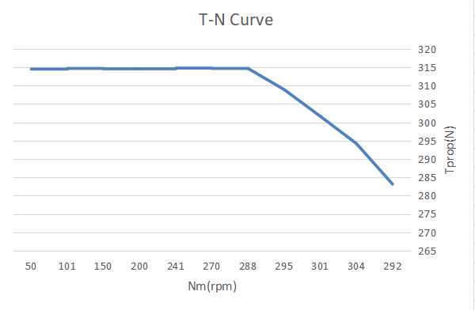

Figure 18 Characteristic curve

## Propeller characteristic curve

The performance of the propeller is usually tested by open water experiments. Normally the performance of the propeller is determined by thrust coefficient (), torque coefficient () and the advance ratio (J). Researchers can calculate the thrust and torque by using these coefficients. Moreover, the thrust coefficient and torque coefficient are inversely proportional with the advance ratio. When , the thrust and torque coefficient reaches their peaks.

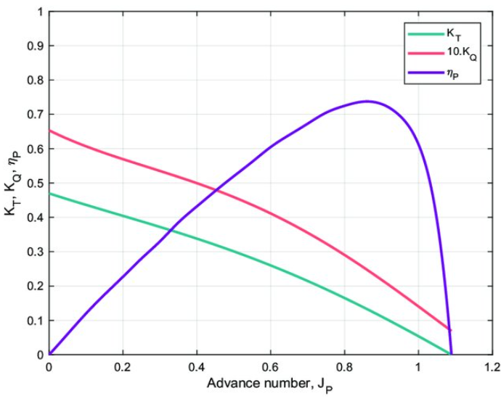

Figure 19 Test results

Represents the efficiency of the propeller in an open water experiment, which is relevant to the thrust coefficient, torque coefficient and advance ratio. The formula of this coefficient will be introduced later.

# Method

## Overview

The method used in this project is the V-Model method with the main structure shown in Figure 20.

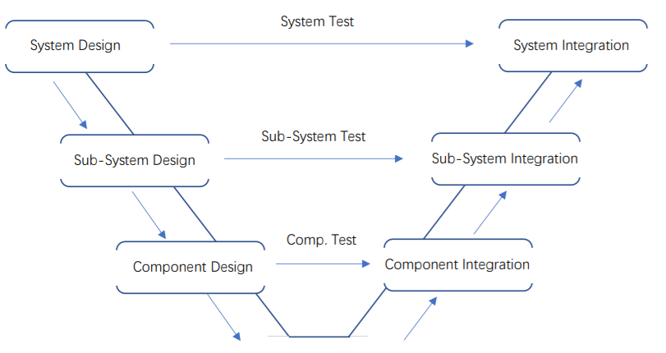

Figure 20 V-model structure

The V-Model can be divided into two main phases: ‘Design Phase’ and ‘Integration Phase’.

In the Design Phase, the behaviors and edges of the final product should be decided and evaluated. In the Integration Phase, focus lies on assembling components, verifying designs in Design Phase and realizing the final product.

The core of V-Model is operating tests and verification. There are several progressive layers in both phases from system to sub-system to component. In the Design Phase different test plans are designed which are used in the corresponding layers in the Integration Phase.

## Reasons of choice

In this propulsion system design project, there is a clear final product idea (fixed component composition, fixed working principle) which gives the team chances to optimize the same idea and guarantee a better functionality of the result. The reason we chose the V-model, is because you do a lot of testing when following the model. Excessive testing is needed to verify our simulation. Especially for this particular propulsion system, every component in every sub-system has close connections. They play different essential roles in the process of generating thrust (components or sub-systems are all related to energy input, output and transmission).

Because every part of the calculation chain has a close connection to each other, we must make sure that the relationship between every part is correct. We must recall and check if there are errors in previous parts before starting a new part. This regularly means going backwards checking for mistakes is necessary. Compared with other methods, the progressive layers of V-Model ensures that the problem and its direction will be recalled and changed effectively. The team can detect the error sources and make targeted improvements easily.

## Usage of method

First, the team has to make the system overview. In order to figure out how system works, disassembling the main system into sub-systems and into components is needed. For every layer, a system description, sub-system descriptions or component descriptions should be taken as the start of the layer. All these descriptions should contain all variables which are related to the input and output of the systems or components. According to these descriptions, the reactions within systems and components can be known and vague elements can be eliminated.

From the system and component descriptions, the design concepts and test plans can be created. In the main system layer, tests will be designed to show the working state of system such as working efficiency and thrust generated by whole propulsion system. In the sub-system layer, tests will be designed, proving relationships between certain sub-systems. For example, the energy transmission/consumption and the power transmission system. In the component layer, the calculation chain will be designed. Tests will be designed to find out the characteristic of every component such as the relationship between the number of gear teeth and the rotation speed.

After finishing all the designs, the components should be reassembled into sub-systems and into a system. The test results from deeper layers will be used in tests from shallower layers. All designs can be validated. When errors appear, the error sources can be found in the corresponding deeper layers.

The following list shows the deliverables of every phase and layer:

|  |  |
| --- | --- |
| Layer | Deliverables |
| Design Phase | |
| System Design | 1. List of demands. 2. Function overview. 3. Analysis of the current situation. 4. System description. 5. System test plan. |
| Sub-System Design | 1. System division. 2. Formula overview. 3. Subsystem description. 4. Subsystem test plan. |
| Component Design | 1. List of components. 2. Component description. 3. Component test plan |
| Integration Phase | |
| Component Integration | 1. Component ordering. 2. Component test. |
| Sub-System Integration | 1. Subsystem assembly plan. 2. Subsystem assembly. 3. Subsystem simulation. |
| System Integration | 1. System assembly plan. 2. System assembly. 3. System test. |

# Bibliography

*Annual Average Wind Speeds in the Netherlands*. (2010). Retrieved from Current Results weather and science facts: https://www.currentresults.com/Weather/Netherlands/wind-speed-annual.php

k.Michaelis&B.-R.Hohn. (n.d.). *Influence of Lubricants on Power Loss of Cylindrical Gears.* Retrieved from Taylor and Francis Online: https://www.tandfonline.com/doi/abs/10.1080/10402009408983279

Klaus Michaelis, B.-R. H. (2011). *Influence factors on gearbox power loss.* Retrieved from https://mediatum.ub.tum.de/doc/1323611/file.pdf

Lauer, D. A. (2013). *Gear Lubrication.* Retrieved from Encyclopedia of Tribology: https://link.springer.com/referenceworkentry/10.1007%2F978-0-387-92897-5_19#howtocite

Lin Zou, M. D. (2018, 6). *Numerical Simulation of the Churning Power.* Retrieved from Wuhan University of Technology: https://pdfs.semanticscholar.org/ef43/b4a9f1f400e9fefe3b8d3c2f5841b9e99c18.pdf

*Major Ocean Currents*. (n.d.). Retrieved from national weather servies: https://www.weather.gov/jetstream/currents_max

*North Atlantic Current*. (n.d.). Retrieved from wikipedia: https://en.wikipedia.org/wiki/North_Atlantic_Current#:~:text=The%20NAC%20flows%20northward%20east,crosses%20the%20Mid%2DAtlantic%20Ridge.

Shi1, W., & Grimmelius, D. S. (2009). *Analysis of energy conversion in ship*. Retrieved from https://www.witpress.com/Secure/elibrary/papers/ESUS09/ESUS09041FU1.pdf

*Waterinfo-Wave*. (2020, 9 19). Retrieved from waterinfo: https://waterinfo.rws.nl

Willemsen, D. (2019, April 7). *Currents*. Retrieved from Currents & Navigation: https://www.sailingissues.com/navcourse8.html